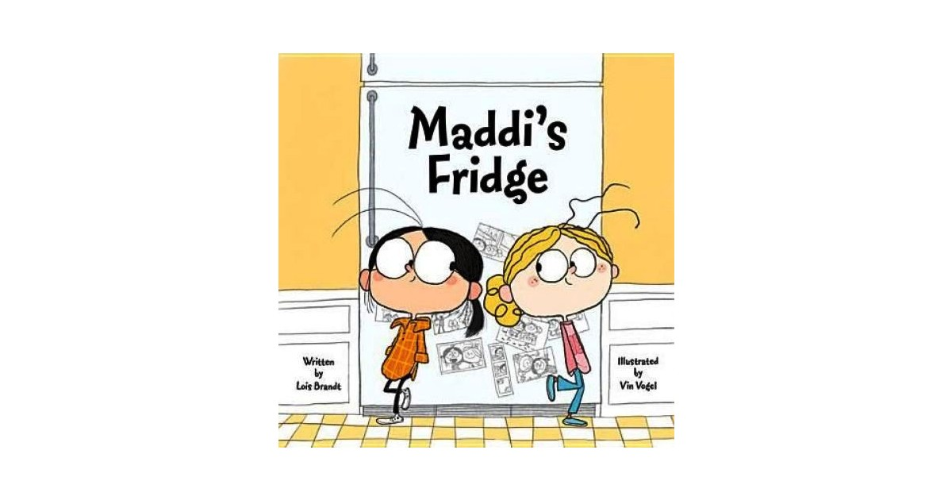Rockwell Elementary, in cooperation with University Book Store, is pleased

to offer the opportunity to pre-order Lois Brandt's book, *Maddi's Fridge*,

for her school visit on **December 6th and 7th**.

Don't miss this exciting event! Have this popular author sign

and personalize your books!

To purchase books for this event, please fill out this order form

and return to the school library **by Wednesday November 30th.**

**UNIVERSITY BOOK STORE ORDER FORM**

|  |  |  |  |  |
| --- | --- | --- | --- | --- |
| **TITLE** | **PRICE**  (includes tax) | **QTY:** | **AUTOGRAPH ONLY** | **OR…**  **PERSONALIZED TO:** |
| Maddi's Fridge (Hardback) | $19.66 |  |  |  |

**TOTAL COST:_______________________**

Your name: ___________________________________ Phone number: ____________________

Your child’s full name: _________________________________ Teacher: ____________________

Please enclose cash or check for the total amount. **PAY TO THE ORDER OF UNIVERSITY BOOK STORE**. If you prefer to pay by credit card, University Book Store accepts MC, Visa, American Express, Discover and University Book Store credit cards:

Account #: _______________________________________________ Exp. Date: ______________

Signature: _______________________________________________

UNIVERSITY BOOK STORE

990 102nd Avenue Northeast, Bellevue, WA 98004

(425.462.4500)

[www.bookstore.washington.edu](http://www.bookstore.washington.edu/)